CONL708: Assignment 5: Pseudocode and Flowchart Diagram

Word Count: 190

I completed this report independently

27/09/2022

To predict whether an insurance company will insure a property, using Classification - observations falling into a particular class out n classes [2] - such as sets of information including house price as a pre-cursor of risk It would take, for the likelihood to insure said property. The following flowchart attempts to portray how events of a Machine Learning process occur to predict whether to insure a property, based on training against historical data of previous decisions from that insurance company [1]. 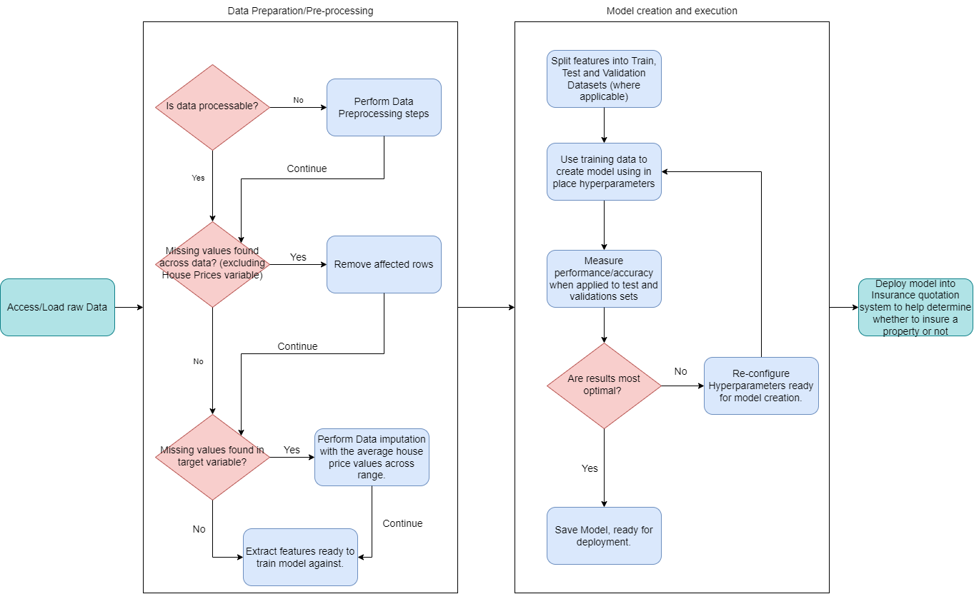

Figure - Flowchart of simple ML process

The below pseudocode attempts to provide the rough logic a Machine Learning process would take upon such a scenario.

IMPORT dataset

PRE-PROCESSING steps on dataset

IF feature_name == “house_price” && value == nan:

THEN house_price.value == Average(house_price.value)

ELSE IF feature_name != “house_price” && value == nan:

THEN remove entire record

SPLIT dataset into Train, Test, and Validation sets

CREATE Model on Training dataset

RUN Model on Test and Validation datasets

ASSESS performance of model

WHILE Optimised model performance == FALSE

IF Accepted_model_performance == FALSE

THEN Retune hyperparameters

ELSE

Break

RECREATE Model on Training Dataset

RUN model on Test and Validation Datasets

ASSESS Model performance

SAVE Model

DEPLOY MODEL

# References

[1] J. D. Kelleher and B. Tierney, Data science. Cambridge, Massachusetts ; London, England: The Mit Press, 2018, pp. 171–178.

[2] Kirill Eremenko, Confident data skills : master the fundamentals of working with data and supercharge your career. London: Kogan Page, 2018, p. 105.